Name:_______________________________ Test Date:_________ Hour:_____
Unit G Study Guide
- Name 2 historical events in space exploration. (Act. 85)
- ________________________________________
- ________________________________________

- The Sun is an average sized ________________. (Act. 92)

- Circle the gas planets in the model below. (Act. 89 in notebook)
Put a square around the terrestrial (rocky) planets in the model below.
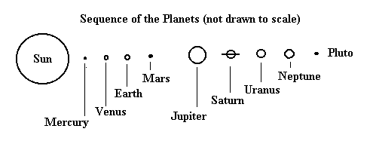

- Why is Pluto no longer a planet? (Act. 88 ACE response) _____________________________________________________________________________________________________________________________________________________________________________________________

- Cross out the place on the list below that humans have not yet visited. (Act. 85 in notebook)
Places
Mars
Moon
International Space Station
Earth’s Orbit
- Circle the object(s) from the list below that orbit another object in our Solar System.
Moon
The Sun
Jupiter
Mars

- Define Solar System. ______________________________________________________________________________________________________________________________

- What is the name of our galaxy? ____________________________________

- A moon must orbit a __________________.

- What is the difference between a planet and a star? ______________________________________________________________________________________________________________________________

- Where does most of the energy that fuels life on Earth come from? (Act. 92)
_______________________________________________________________
- Name the planets in order from the Sun (first letter of planet is given), and give ONE fact about each planet. (Act. 89)
- M___________________________________________________________
- V___________________________________________________________
- E___________________________________________________________
- M___________________________________________________________
- J___________________________________________________________
- S___________________________________________________________
- U___________________________________________________________
- N___________________________________________________________

- Astronauts feel “weightless” in space because they are constantly falling _________________ Earth. (Act. 96)

- If a satellite slows down while orbiting Earth, it will ____________________.

- Moving farther away from Earth would cause the gravitational pull between you and Earth to __________________________ (increase or decrease).

- If you visit a planet that has 3 times more mass than Earth, what would you expect to happen to your weight?
- It would stay the same.
- It would increase.
- It would decrease.
What would happen to your mass? A. It would stay the same. B. It would increase. C. It would decrease.
- Name two ways that the telescope has helped astronomers. Give an example of each. (Act. 87)
- ____________________________________________________________
____________________________________________________________
- ____________________________________________________________
____________________________________________________________
- Review your notes for Act. 90. Make sure you know things that you should see on an accurate model of the Solar System.
- Review your data/analysis for Act. 93. You will need to know how to read a false-color topographical map in order to describe the landscape it shows.
- Review the data from Act. 97. You will need to know one advantage and one disadvantage for piloted vs. unpiloted space missions.
- Review vocabulary section of your notebook. Practice using quizlet link from my website. mrsmaston.weebly.com

