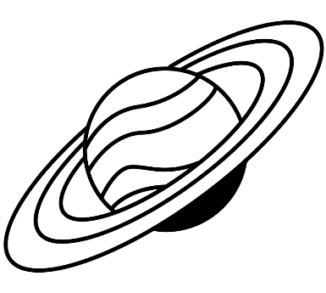
Space Object RESEARCH PROJECT

Name: ___________________________ Hour:_____

Object:___________________________ Due Date: _________

As we have learned in class, space is full of different objects! You have the opportunity to research an object that interests you. Some of these objects are a type of object while others have specific names given to that particular type. Now it is time to learn more about your space object!

Space Objects
- Star
- Planet (Mercury, Venus, Mars, Jupiter, Saturn, Uranus, Neptune)
- Black Hole
- Solar System
- Galaxy
- Moon
- Dwarf Planet (Pluto, Ceres, Eris, Makemake, Haumea)
- Meteorite
- Comet
- Nebulae
*If you would like to research an object not listed, it must be approved by the teacher prior to starting your research.

1) TASK: Research a space object and create a detailed PowerPoint presentation, brochure, video (3 min or less), or poster (circle one) with the information you have discovered. Upon completion, you will present your project to your classmates. If you have another idea for your presentation, please ask your teacher.

2) REQUIREMENTS:
Your project must include each of the following:
Name of Space Object
How It was Discovered? (ex: who, when, with what technology?)
☆ Where is it located? (ex: in our solar system? Could they be anywhere? In all solar systems?)
☆ Why you chose this object
4-5 Interesting Facts about your object
- How does it move? (revolve? Orbit?)
☆ Two or more pictures
☆ Cite websites/books that you have used – You must use at least 3 different websites or books.

Note: PLEASE make sure you understand your facts and vocabulary that you use on your project. Do additional research if necessary to understand the required information. Facts that are clearly copied/pasted from sources will NOT count!

POSSIBLE ONLINE RESOURCES- circle the ones you use

- Nasa.gov
- https://www.iau.org/public/themes/naming/
- https://spaceplace.nasa.gov/menu/solar-system/
- https://airandspace.si.edu/
- https://exoplanets.nasa.gov/
- http://www.spacescoop.org/en/topics/
- https://stardate.org/search/site
- https://www.windows2universe.org/
- Earth & Space (I-Science Book)

There are many more websites and than just these that are listed. Feel free to use any good sources you find. Make sure you keep track of each website used!

Other sources:
- _____________________________________________________________

- ______________________________________________________________

- ______________________________________________________________

- ______________________________________________________________

- ______________________________________________________________

My Research

NOTES:
Object
Why did you choose this object?
How and when it was discovered?
Where is it located?
4-5 Interesting Facts
How does it move?
Websites

